**CII 2021 Spring Conference Member-Hosted Meeting**

**GRI’s Global Tax Standard 207 and the Investor Case for Country-level Corporate Tax Disclosure**

**March 8th | 2:45-3:45 pm ET |** [**REGISTER**](https://oxfam.zoom.us/meeting/register/tJIvc-6rpjMiHN365sY6RbtcDy1El0Oz-V6I)

2021 is set to be a big year in corporate tax transparency. Investors, analysts, data providers, legislators and the general public alike are increasingly interested in understanding how companies approach tax-related issues. A healthy corporate tax system can drive sustainable development, finance essential public services and help to mitigate climate risks. With the first global standard on tax transparency (GRI 207) set to go into effect in 2021 and FASB exploring enhanced income tax disclosure, institutional investors and analysts are increasingly calling for greater transparency to evaluate companies’ exposure to potential earnings, governance, reputational and broader societal and macroeconomic risks emerging from tax practices.

To help unpack the benefits of this new standard for investors, CII members Oxfam America and UAW Retiree Medical Benefits Trust invite you to attend this meeting and learn from fellow investors who are already using country-level tax information, understand the investor case for greater country-level disclosure in this area, and learn how investors can encourage enhanced corporate tax transparency.

**Program**

*Welcome*: Meredith Miller, Chief Corporate Governance Officer, UAW Retiree Medical Benefits Trust

* *The ESG and material cases for responsible tax:* Rob Wilson, Investment Officer and Research Analyst, MFS Investment Management (MFS)
* Experience of investors engaging companies on tax: Vaishnavi Ravishankar, Senior Analyst, ESG, Principles for Responsible Investment (PRI)
* *GRI as a useful new tool for investors, analysts and companies:* Eelco van der Enden, Partner | Global ESG TLS Lead, PwC
* *Why tax transparency is critical to understanding company risks:* David Gonzales, VP-Senior Accounting Analyst, Moody’s
* *Experience implementing new tax transparency tools, including public country-by-country reporting*: Zahira Quattrocchi, Group Head of Tax, Anglo American

*Moderator*: Niko Lusiani, Senior Advisor, Private Sector Department, Oxfam America

*Register in advance for this meeting here:*

<https://oxfam.zoom.us/meeting/register/tJIvc-6rpjMiHN365sY6RbtcDy1El0Oz-V6I> *After registering, you will receive a confirmation email containing information about joining the meeting.*

**Speaker Biographies**

**Meredith Miller, Chief Corporate Governance Officer, UAW Retiree Medical Benefits Trust**

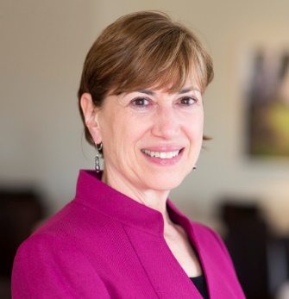

Meredith Miller is the Chief Corporate Governance Officer of the UAW Retiree Medical Benefits Trust (“Trust”). The Trust was established in 2010 as a Voluntary Employee Beneficiary Association (VEBA) to pay the medical benefits for 700,000 UAW retirees. The Trust is the largest non-governmental provider of retiree health in the U.S. and has assets of $59 billion. Ms. Miller oversees the Corporate Governance Program of the Trust for domestic and international equities, including proxy voting and corporate engagements on board governance issues such as diversity, executive pay, human capital management, and compliance. Ms. Miller received a Bachelor of Arts degree from Hampshire College, Amherst, Massachusetts and her Master’s of Science from the London School of Economics, London, England. She has served as a Trustee on the board of Hampshire College and as a Director on the board of the Council of Institutional Investors. Currently, she is serving as a Director on the Board of the Global Reporting Initiative and of the Thirty Percent Coalition.

**Rob Wilson, Investment Officer and Research Analyst, MFS Investment Management (MFS)**

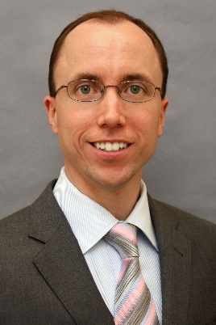

Rob Wilson is an Investment Officer and Research Analyst at MFS Investment Management (MFS). Rob works with the firm’s other analysts and portfolio managers to integrate environmental, social and governance (ESG) research into MFS' financial modeling, valuation, and portfolio construction decisions. Rob is a member of both MFS' Proxy Voting Committee and our impact investment steering group. Rob joined MFS in 2013 after six years with American Century Investments, where he served as an equity analyst. Previously, Rob spent five years at Bain & Company, working as a manager in the Financial Planning & Analysis group. Rob earned a bachelor of science in business administration from Boston University and a Master of Business Administration from the University of Chicago.

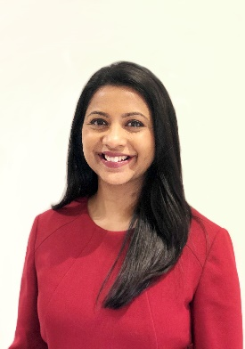**Vaishnavi Ravishankar, Senior Analyst, ESG, PRI**

Vaishnavi has worked in responsible investment over the last ten years. She currently works as a senior analyst within the ESG team at the UN-supported Principles for Responsible Investment (PRI), managing corporate governance focused workstreams, such as tax, political engagement, cyber security, and executive remuneration. Over 2017-2019, she coordinated PRI’s collaborative engagement on corporate tax transparency which involved over 35 institutional investors representing USD3trn in AUM. Prior to joining the PRI, Vaishnavi worked for CAER, an Australian based ESG research service provider. In this role, she assessed corporate ESG performance, developed ESG position papers and thematic research papers for institutional investors. She has a Bachelor of Commerce, majoring in Accounting and Finance from the Australian National University (ANU) and a Graduate Certificate of Law at the ANU.

**Eelco van der Enden, Partner | Global ESG TLS Lead, PwC**

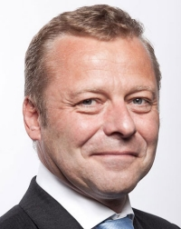

Eelco van der Enden leads PwC’s global ESG Tax & Legal Services platform and Tax Administration Consulting practice. He supports public and private sector organisations adjusting their tax operations to an ESG-focused economy. Eelco is a member of the Global Board of Directors of GRI and  was a co-writer of the GRI 207: Tax standard. Eelco is also Chairman of the Tax Policy Group of Accountancy Europe, member of the EU GTG Committee and has published more than 50 articles on tax governance and reporting.

**David Gonzales, VP-Senior Accounting Analyst, Moody’s**

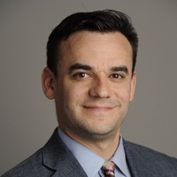

David is a member of Moody’s Accounting Specialist Group where he is dedicated to simplifying complex accounting/financial reporting issues and incorporating them into the ratings process within the global Corporate Finance Group (non-financial companies). He is also active with the Financial Standards Accounting Board (FASB) as a member of the Financial Accounting Standards Advisory Council (FASAC) and the Taxonomy Advisory Group (TAG). Previously, David worked for Ernst & Young and was part of the Technical Accounting Advisory Group as a subject matter specialist overseeing various technical subjects. Prior to his work with EY FAAS David worked 8 years as part of the audit practice in Southern California and three years in Netherlands where he covered audits exclusively in IFRS and local GAAP.

**Zahira Quattrocchi, Group Head of Tax, AngloAmerican**

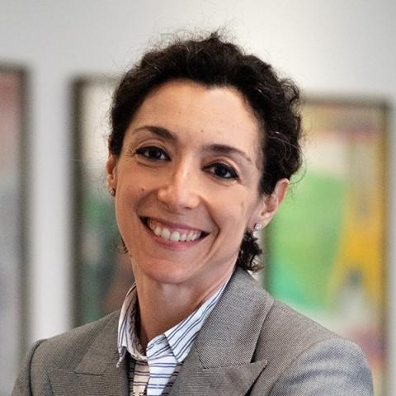

Zahira Quattrocchi has been Group Head of Tax at Anglo American since April 2019. Zahira joined Anglo American in from CNH Industrial, one of the world's largest capital goods companies. Prior to that, she was Global Head of Tax at Italian food processing company, Barilla.  A trained lawyer, Zahira has practised in Italy where she started her career in EY and then moved to Industry working for Bayer and Shell.  As well as a wealth of experience in multinational transfer pricing, restructuring and tax compliance, Zahira is a leading authority on tax audits.  A regular speaker at events, Zahira has contributed to the debate around Cooperative Compliance, Transparency and Good Tax Governance. Under Zahira’s leadership, Barilla was admitted between the 9 MNEs piloting the OECD International Compliance Assurance Program.

**Niko Lusiani, Senior Advisor, Private Sector Department, Oxfam America**

Niko Lusiani is Senior Advisor in Oxfam America’s Private Sector Department, where he combines research, policy advocacy, investor and company engagement toward advancing more transparent and equitable economic and tax policies. In an investor capacity, Niko engages major public companies on corporate governance, in particular on tax. Niko is also Oxfam’s lead in engaging the pharmaceutical sector. He received a Master’s degree from the School of International and Public Affairs at Columbia University, has written extensively on corporate taxation, and on behalf of Oxfam contributed to the creation of the GRI 207 Tax standard.

* * *